Eurasian National University named after L.N. Gumilyov

Faculty of «Information Technologies»

Department of «Information Systems»

**Independent work of the student: 2**

**by discipline** «Development of client server IS»

**Student:** Iskakov Y.K.

**Group:** IS-35

**Checked by:** PhD. Akhmetova. A.Z.

**Independent work of the student: 2.**

**Table of contents**

|  |  |  |
| --- | --- | --- |
| 1 | Screenshots | 3 |

**Screenshots**

**Create Table**

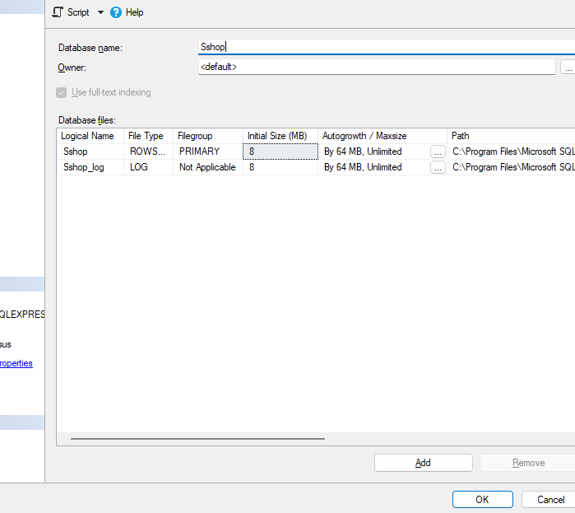

Customers

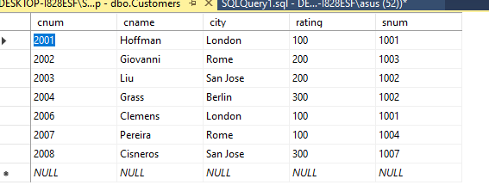

Orders

Salespeople

